BAY AREA BORDER RELIEF www.BayAreaBorderRelief.org
Twitter @BorderRelief Facebook @Bay Area Border Relief
bayareaborderrelief@gmail.com
bit.ly/BABRatPVF

FOR IMMEDIATE RELEASE Contact:

Lia Turk
650.400.3919 cell
liaturk@gmail.com

Lilli Rey
650.288.5820 cell
ljrey@mac.com

Belinda Hernandez-Arriaga
650.243.1725 cell
bmhernandezarriaga@usfca.edu

Terry Sprague
650.303.5593 cell
terrysprag@aol.com

*** MEDIA ADVISORY ***

BAY AREA BORDER RELIEF TEAM OF 24 RETURNS
FROM FIFTH HUMANITARIAN VISIT TO TEXAS BORDER
Volunteers Offer Compassion, Meals, a Makeshift Altar and Humanitarian Support
to Asylum Seekers in Crisis at Matamoros, Mexico Tent Encampment

Berkeley, CA – October 30, 2019 – Bay Area Border Relief (BABR) volunteers have just returned from six days of direct, hands-on, humanitarian support, October 19 to October 25, 2019, to address the growing humanitarian crisis at the south Texas border. BABR provided donations and dinners to over 1,000 children and families now stranded in Matamoros, Mexico, as a result of U.S. immigration policy, specifically the “Migrant Protection Protocols” (MPP).

24 BABR members, from all over the San Francisco Bay Area, collaborated with Team Brownsville, Mateo 25:35, Catholic Charities Rio Grande Valley and a local Matamoros pastor to prepare and serve four consecutive dinners to the encampment of 1,000+ (some reports say closer to 2,000) residents, with dozens more being returned to Mexico daily from Customs and Border Patrol (CBP) and/or Immigration and Customs Enforcement (ICE). These new arrivals are dropped off with only the clothes on their backs, many with young children in tow. Volunteers from nonprofits and religious organizations attempt to provide tents and basics, when available, usually transported on foot via wagon over the bridge.

One of the dinners each week is coordinated by Pastor Abraham Barberi, who heads Comunidad Esencia Urbana, a hip-hop oriented, non-denominational church. As migrants line up to receive the free meal, he creates a lively, beat-punctuated, music-filled dinner distribution every Wednesday night in the camp at the foot of the International Bridge in Matamoros, in coordination with volunteers. Team Brownsville recruits and organizes volunteers from all over the country to cook and serve the rest of the week’s dinners, doing so since summer 2018; the group Angry Tias and Abuelas also arranges a breakfast service.

BABR volunteers included University of San Francisco (USF) faculty and graduate students from the USF School of Education and Notre Dame de Namur University who are trained and equipped to deal with the stress, trauma and anxiety related to the migrants’ treacherous journeys to this border region. After sitting in the blazing sun filling out I-589 forms to assist one family with their immigration documents and paperwork, Belinda Hernandez Arriaga, EdD, LCSW, University of San Francisco Counseling Psychology Department, learned that the family really wished for a small portable altar and/or cross to bring light and faith to each tent in La Plazita/The Plaza. BABR’s Hernandez Arriaga went on a personal mission to find exactly these requested elements, purchasing a cross, Virgin Mary statue, and also adding multi-colored camping lights. She had hoped that the items could have been blessed by a priest, but time was scarce and no priest had been seen in the encampment during BABR’s visit. Hernandez Arriaga arrived home heartbroken that she was not able to do more to honor this request in Matamoros. Her new migrant friends followed up with a video clip of the altar, its twinkling lights and a small procession they created for it. The neighbors in the tent city are now gathering at this site to pray. A beautiful, colorful little altar bringing light and hope as a source of faith and strength for all.

Lo and behold, the same day that BABR departed Matamoros to return back to the SF Bay Area, the asylum seekers had created a stunning altar, with salvaged materials surrounded by the light sticks and a priest, Fr. Bruce Nieli from Austin, happened to drop by, started strumming guitar, singing and ultimately blessed the small altar. Fr Nieli also celebrated mass in the midst of the tent city using the cross statue bought for the little altar, set up on overturned buckets, placed on top of one of the Sunday school puzzle mats, decorated with donated rosaries. Subsequently, there was much talk about miracles…

This priest had come two days in a row to pray and sing with them. “He appeared out of nowhere--and they are so excited,” Hernandez Arriaga remarks. “Their smiles and joy amidst such hardship is comforting. Their faith sustains them through it all and is a faith greater that we can imagine.”

Current figures estimate approximately 2,000 people within the tent city that has emerged in the vicinity of the main plaza and adjacent to the Gateway International Bridge between Matamoros and Brownsville, TX. This refugee camp was organically established in summer 2018, initially with 100-200 residents, but has grown significantly since summer 2019. Although Mexico’s president, Andres Manuel Lopez Obrador, agreed to the MPP policy, once the U.S. government threatened tariffs, neither the government of the city of Matamoros nor the state of Tamaulipas are able to provide much assistance.

Rows and rows of colorful tents cluster together to form a squalid, makeshift encampment of migrants, developed adjacent to the Rio Grande and just beyond the Gateway International Bridge from the U.S. into Matamoros, due to MPP, also known as “Remain in Mexico,” which forces migrants to wait in Mexico until their assigned court dates for their asylum case hearings. The BABR team met people again on this trip, who were still waiting and with whom they had originally connected in June 2019. A wait of multiple months wait is not uncommon. All are awaiting court dates and decisions on asylum claims. Many organizations and media have reported that conditions in the camp are deteriorating. Temperatures have ranged from blistering heat to extreme cold and these families with children are terrified to leave the plaza for any other shelter, as Matamoros is known to be a dangerous drug-cartel controlled city, with many kidnappings and a U.S. State Department Level 4 Travel Advisory zone. This is the highest advisory level due to greater likelihood of life-threatening risks.

There is no regularly running water and the small number of porta-potties are insufficient for the thousands encamped there. A volunteer from the Asylum Seeker Resource Center in Mexico, with the assistance of BABR-affiliated Kate Luna, has recently set up a few showers, as families have been bathing in the contaminated Rio Grande river, amongst deceased human and animal remains and rumors of alligators. There is great potential for health crises as a result of the deplorable conditions, including cholera. Recent rains have quickly soaked tents and belongings, and mud infiltrates the tents. Mud from the river and recent rains cake flip-flops and Crocs and is difficult to remove without ample water.

In the past week, a plan to relocate residents to another site approximately ten kilometers away was announced and then cancelled, because the tent encampment is on federal land. Both asylum seekers and humanitarian organizations protested the plan, primarily due to the distance away from the bridge and more difficult access to both courts and aid.

BABR volunteers, including professors and graduate students from the University of San Francisco School of Education, also participated in Team Brownsville’s Escuelita de la Banqueta/Sidewalk School for the children of all ages on Sundays. They also offered informal counseling and trauma expertise.

Prior to the trip the BABR team of volunteers sorted through hundreds of bags and boxes of donations from all over the Bay Area of clothing and basic supplies, including sleeping bags, tents, art and school supplies, toiletries, and more, packing them for distribution at the tent encampment of asylum seekers that has developed in Matamoros due to current U.S. policy. Also included were hand-knit caps for the upcoming winter months, from the Burlingame Public Library’s Stitch-It Forward effort and as far away as NH, brand new teddy bears from Caring for Children, hand-written note cards, and bras from Mercy High School in Burlingame and much more. The truck of supplies met the group in TX and was unloaded into the temporary storage of a U-Haul truck and at the Humanitarian Respite Center in McAllen. These were distributed to needy migrants on multiple, consecutive days in the tent city in Matamoros.

The two organizations, both Bay Area Border Relief and Team Brownsville, evolved as grassroots humanitarian efforts in mid-2018 as a result of the Trump administration’s child and family separation policy. Since then they have supported migrants released from mandatory immigration detention, but due to MPP, their work has morphed into addressing the daily needs of the tent city population. The Humanitarian Respite Center in McAllen, TX has been operating continuously since 2014 as a direct approach to restore human dignity by offering daily support to immigrants and refugees, but is currently almost empty, due to the lowest number of immigrants released from immigration detention in the last five years.

With the direct support of Bay Area Border Relief and local coast-side organizations, several Central American immigrant families who passed through the Humanitarian Respite Center in McAllen have recently resettled on the San Mateo County coast. As these families await formal decisions on their applications for legal asylum, they are adjusting to life in the United States and receiving help and wrap-around case management services from BABR volunteers, working together with Half Moon Bay organizations, such as ALAS (Ayudando Latinos a Soñar), the Latino Council of Half Moon Bay, Coastside Advocacy and the local Immigration Action Group, providing assistance with appropriate and affordable housing, educational opportunities, continued counseling/mental health services, accompaniment for immigration/asylum-related appointments and legal consults, English as a Second Language courses, job-training, tutoring and general orientations to life in the United States.

Bay Area Border Relief (BABR) is a humanitarian organization that serves and advocates for children and families seeking their human right to asylum in the U.S. A collaborative and cross-sector organization of local citizens, BABR was inspired by Rep. Jackie Speier (CA-14) to provide a direct and heartfelt response to the child separation crisis of mid-2018 at the U.S./Mexico border area. Congresswoman Speier organized the initial congressional delegation to visit the Texas border area detention centers in June 2018. She also encouraged members of BABR, as concerned citizens, to be on-the-ground witnesses to the impact and effects of the inhumane separation of families and children and their poor treatment in immigration detention.

BABR is 100% volunteer-driven, comprised of University of San Francisco (USF) faculty and other educators, students, philanthropists, nurses, counselors, community activists, film makers, law and human rights advocates and regular citizens. Philanthropic Ventures Foundation acts as BABR’s fiscal sponsor and has also sent staff and supported USF graduate student travel expenses to McAllen, TX. BABR reflects a unique alignment of higher education, philanthropy, community volunteers, non-profits and corporations united to work together towards a common goal of human rights, advocacy and social justice.

“Bay Area Border Relief is a grassroots, citizen-created, humane and compassionate reaction to assist asylum seekers fleeing violence, to counteract our government’s relinquishment of all responsibility. These are our fellow human beings who have journeyed under difficult circumstances to seek a brighter future for their families,” said Lilli Rey, BABR co-founder.

Each individual BABR member had one-on-one conversations and interactions with migrants in the camp and additional stories to share. Several team members concluded their trip to southern Texas with a stop at The Basilica of the National Shrine of Our Lady of San Juan del Valle, a Minor Basilica of the Catholic Church, and an important pilgrimage site in the region.
Financial contributions can be made via Philanthropic Ventures Foundation, bit.ly/BABRatPVF. For more information, please visit www.bayareaborderrelief.org

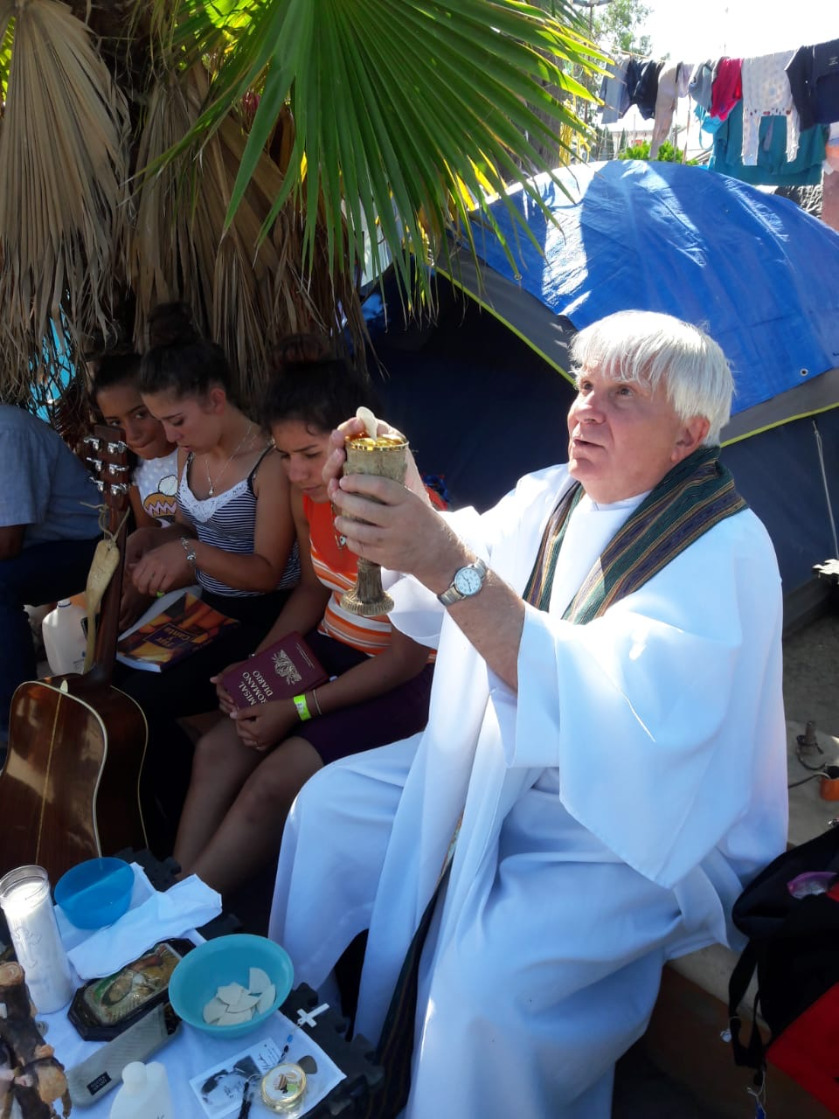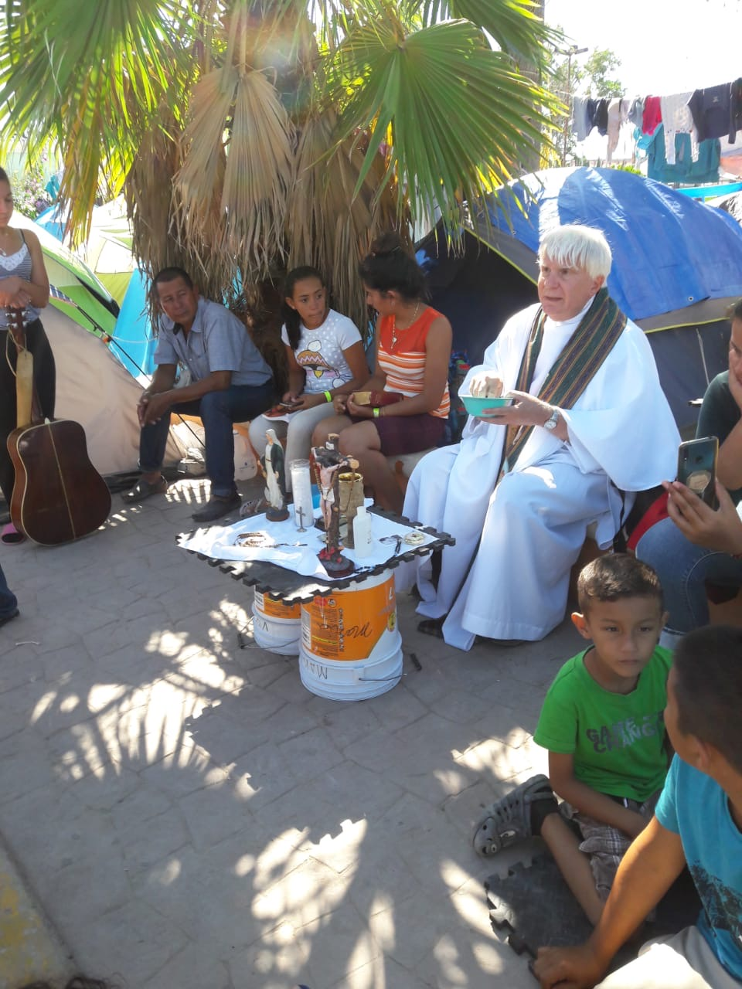

- ###

- Additional photos available from BABR

